UNIT 2
Lesson 6 - I  my home

- 1 Look at the pictures.
Pogledaj slike.
What can you see? Circle the correct word.
Što vidiš na njima? Zaokruži točnu riječ.


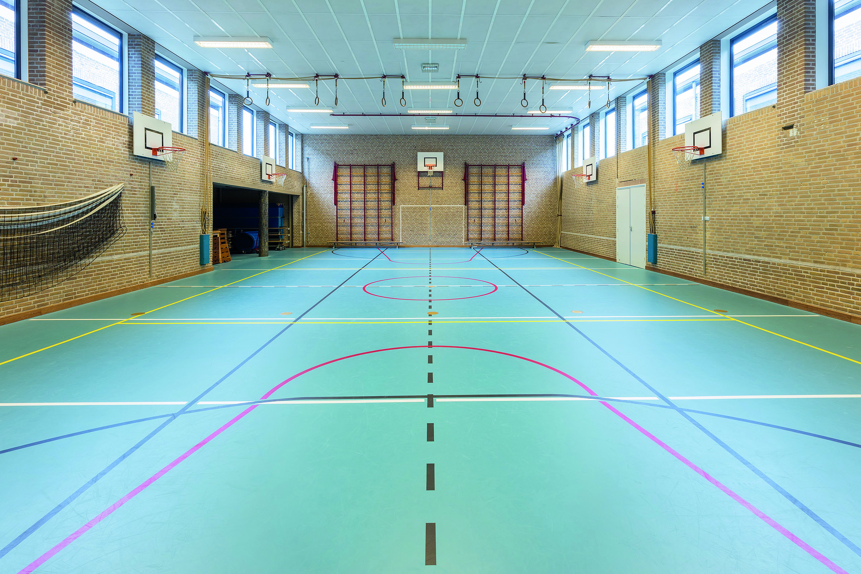

I can see a classroom / a gym. I can see a map / a photo.
Vidim učionicu/ dvoranu. Vidim kartu / fotografiju

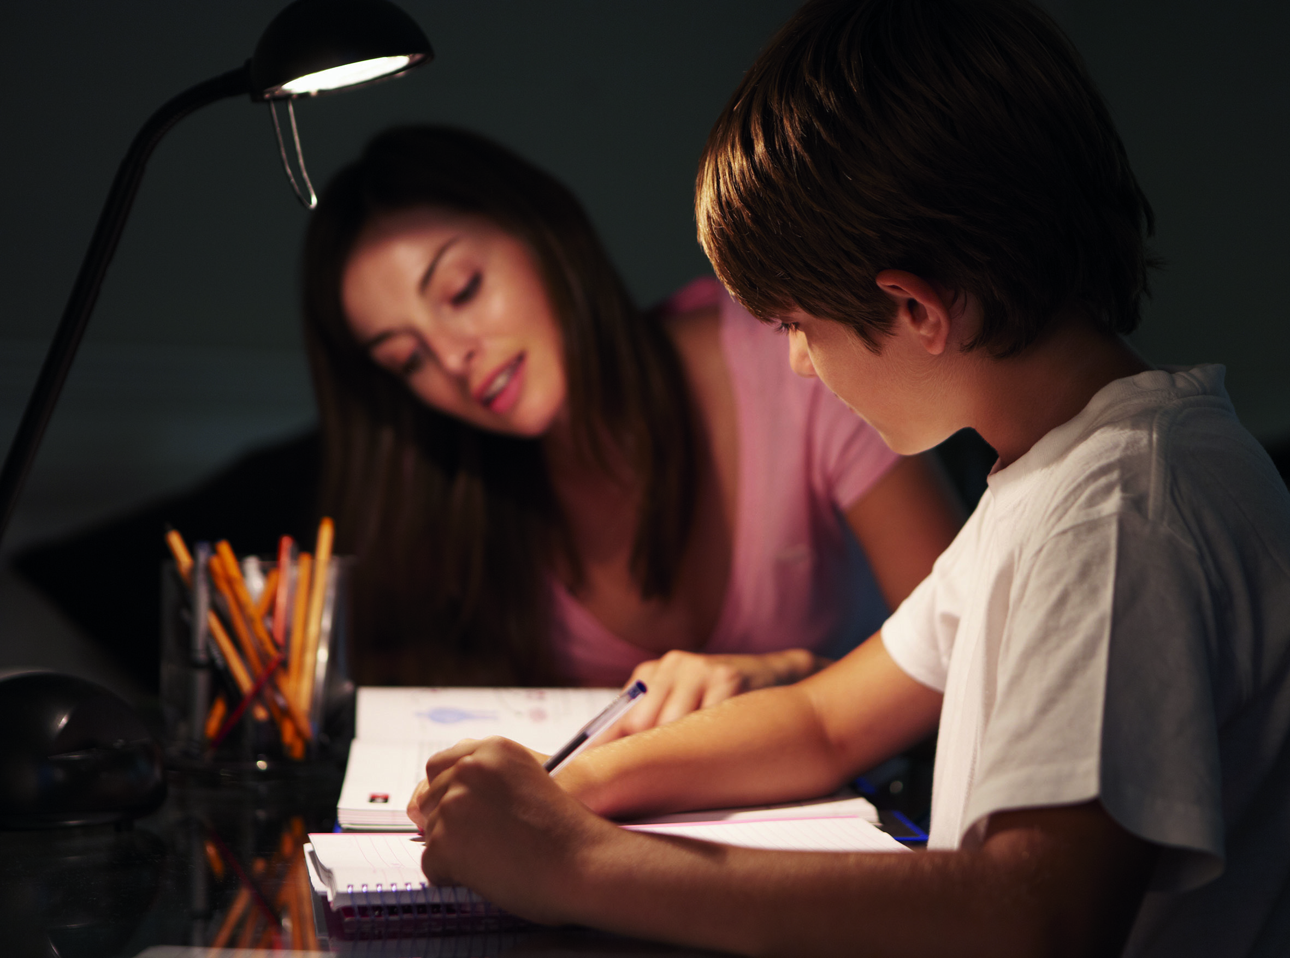

I can see a boy and a girl doing homework / playing.
Vidim dječaka i djevojčicu kako pišu zadaću / se igraju.

- 2 Look at the pictures.
Pogledaj sličice.
Read the words that describe them.
Pročitaj riječi koje ih opisuju.

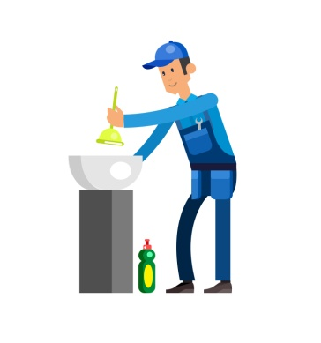



janitor school cook primary school
domar školski kuhar / kuharica osnovna škola

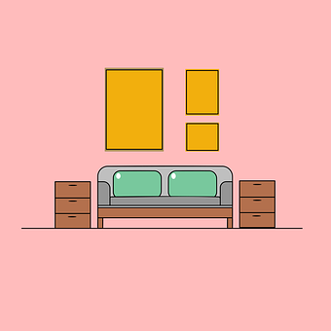



secondary school flat school building
srednja škola stan školska zgrada

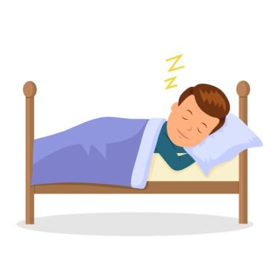
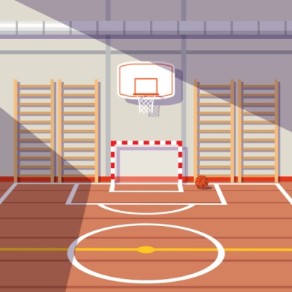
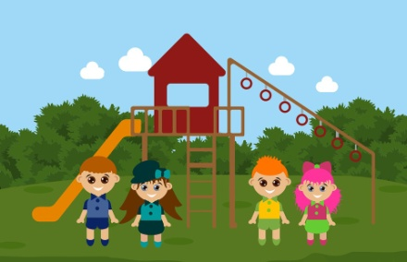

schoolyard school gym sleep
školsko dvorište školska dvorana spavati

- 3 Listen to your teacher /classmate read the sentences.
Poslušaj svog učitelja / prijatelja kako izgovara rečenice.
Point to the correct word.
Prstom pokaži točnu riječ.
Say the word. Translate the word.
Izgovori riječ. Prevedi riječ na hrvatski.

The boy's name is Toni / Ewan.



Ewan goes to Belvedere Primary / Secondary school


in Nottingham.

Ewan’s dad is a janitor / teacher.



Ewan's mum is a nurse / cook.

Ewan's sister, Irene doesn’t like sharing her
computer / tablet.

Ewan likes that he can 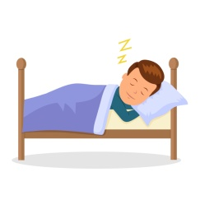 study / sleep

longer before school.

- 4 Read the words in the left frame.
Pročitaj riječi u okviru s lijeva.
Copy them in the right frame without peeking.
Zatim ih bez gledanja prepiši obrnutim redoslijedom.
___________
___________

___________

___________

___________

secondary
school

janitor

cook

tablet

PASCAL'S NOISY HOME
- 1 Look at the pictures. Pogledaj slike.
Read the words. Pročitaj riječi.

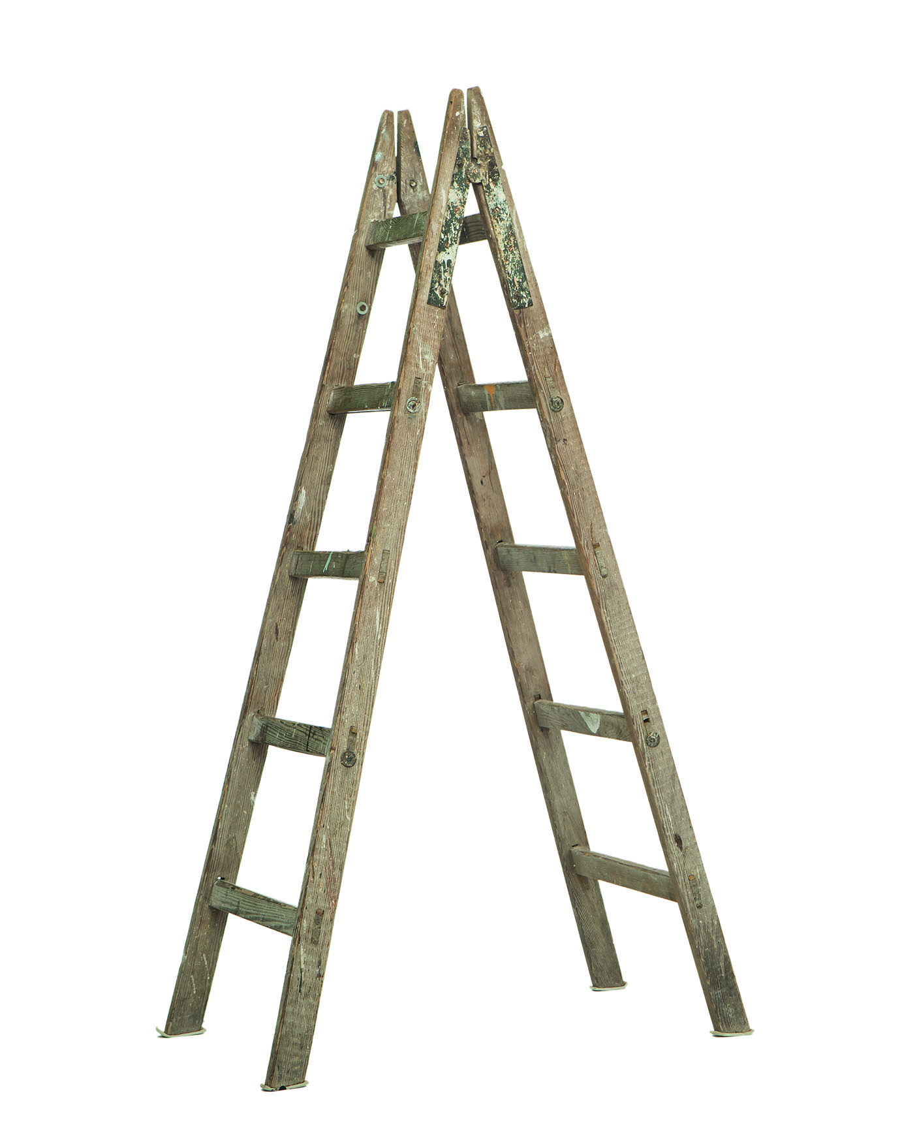
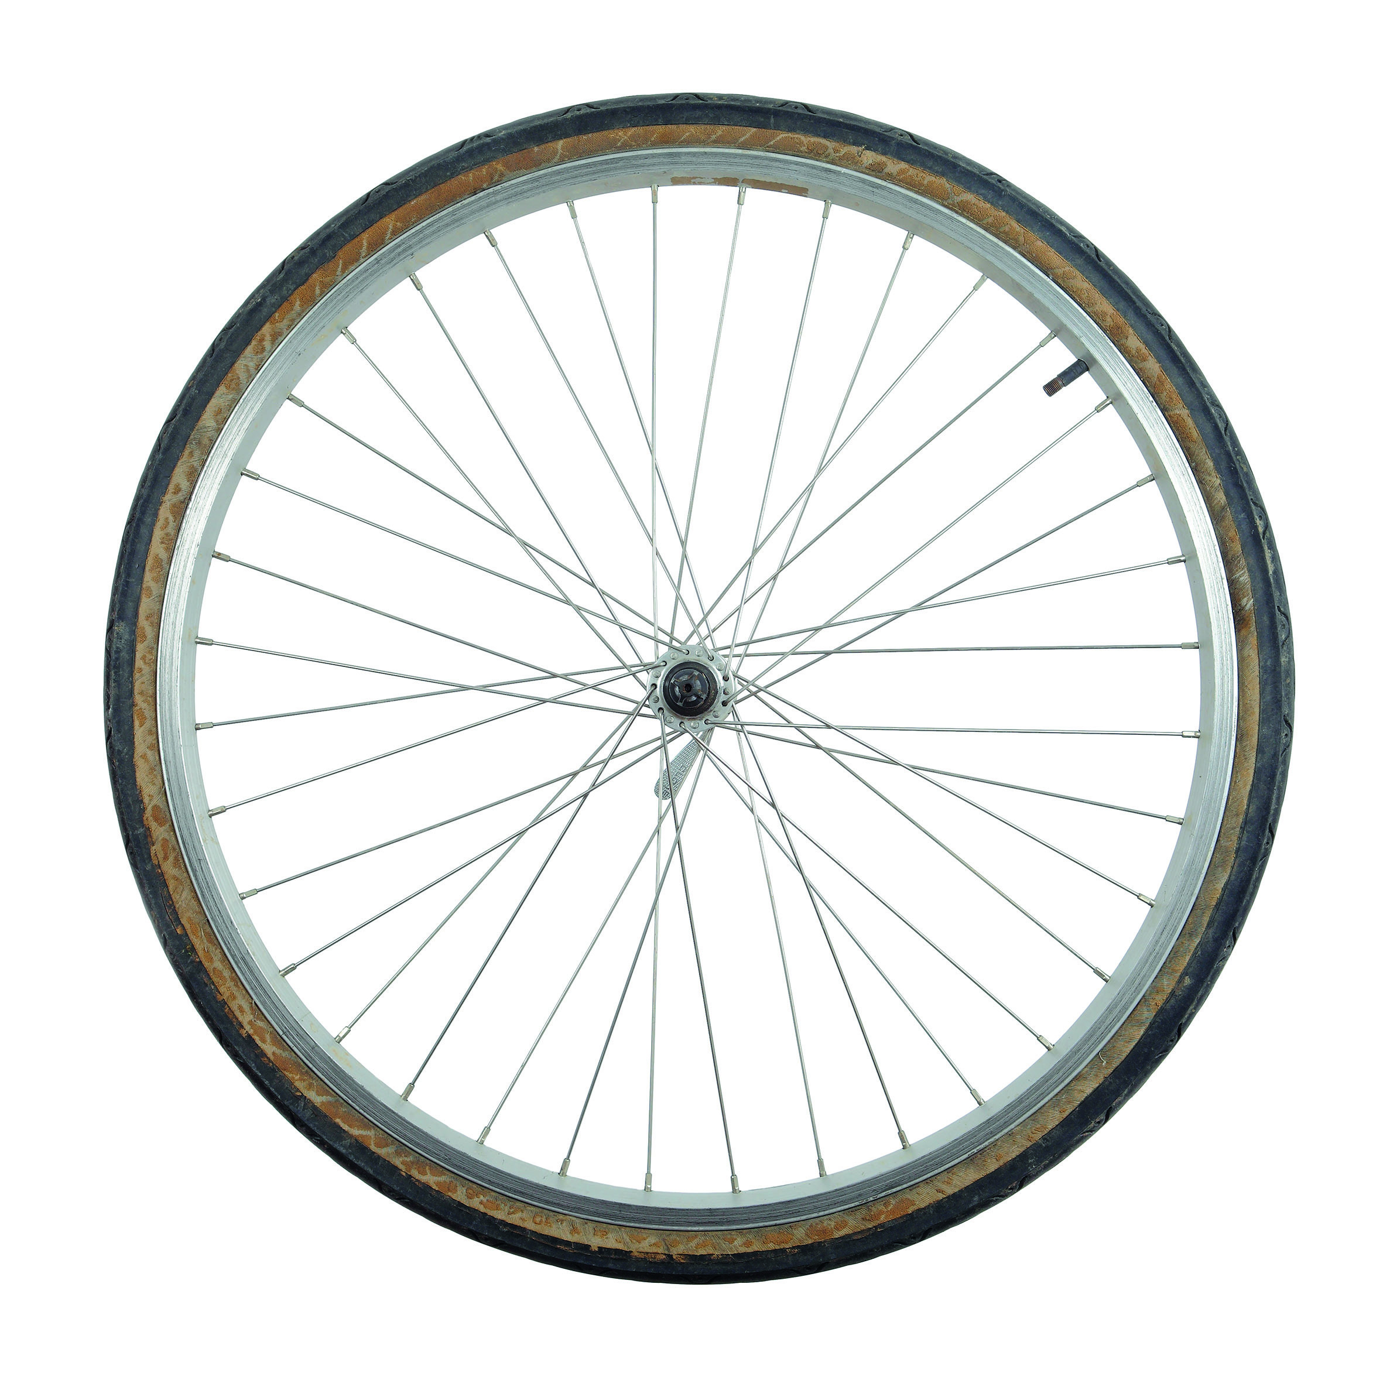

ladder (ljestve) wheel (kotač) cotton wool (pamučna vata)
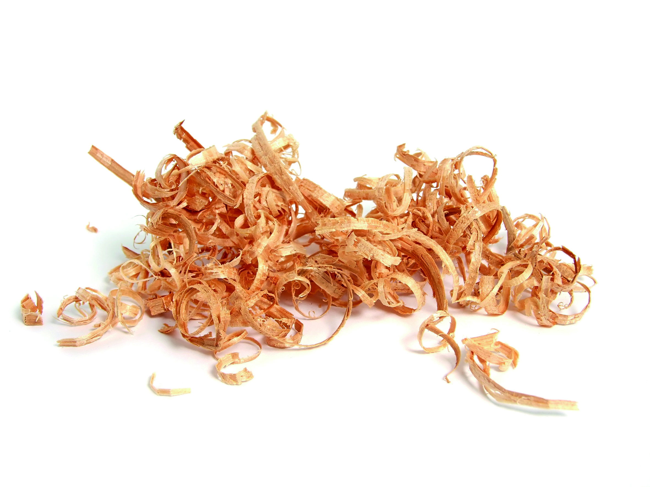

sawdust (piljevina)

- 2 Match the words to the pictures.
Spoji sličice s riječima koje ih imenuju.
Copy the words on the lines.
Prepiši riječi na prazne crte.

A wheel (kotač)

B sawdust (piljevina)

C cotton wool (pamučna vata)

D ladder (ljestve)

1 ______________________

2 __________________

3 __________________

4 __________________

c) Try to work out the riddle.
Pokušaj odgonetnuti zagonetku.

Whose house has  a wheel, 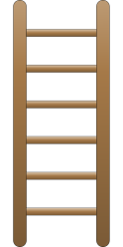 a ladder,

sawdust and cotton?

U čijoj se kući nalazi kotač, ljestve, piljevina i pamučna vata?

Circle the correct answer.
Zaokruži točan odgovor.
a)  a dog (pas) b)  a boy (dječak)

c)  a hamster (hrčak)

- 3
a) Listen  to track 2.4.
Who is talking? Tko priča o sebi?
Circle the correct word. Zaokruži točnu riječ.

a boy (dječak) a hamster (hrčak)

b) Listen to your teacher / classmate read the sentences about Pascal one by one.
Poslušaj svog učitelja / prijatelja kako čita rečenicu po rečenicu o Pascalu.
Put the missing words on the empty lines.
Upiši riječi koje nedostaju na prazne crte.

living (živjeti) night (noć) school (škola)
noise (buka) small (mala) room (soba)
science (znanost)

1 I live at __________________ .
Živim u …

2 I don't like __________________ at school very much.
Ne volim u školi.

3 I don't like the _________________ .
Ne volim

4 Some people think that my home is very _______________.
Neki ljudi misle da je moj dom jako

5 There is only one ___________ in my house - my bedroom.
Samo je jedna u mojoj kući – moja soba.

6 There is a wheel I can run in to keep fit.
Tamo je kotač koji koristim za vježbu i održavanje forme.

7 I only run at _______________ .
On samo trči u noću.

8 The ____________ teacher feeds him and calls him Pascal.
Učitelj ga hrani i zove ga Pascal.

- 4 Read the words in the left frame.
Pročitaj riječi u okviru s lijeva.

Copy the min the right frame without peeking.
Zatim ih bez gledanja prepiši obrnutim redoslijedom.
___________

___________

___________

___________

wheel

cotton wool

ladder

sawdust

